EXPERIMENT NO 1

AIM:TO DEVELOP AND DESGIGN A MOBILE OR WEB APPLICATION AND TO CHANGE THE BACKGROUNND,MENU AND COLOR

PROCEDURE:

\*CREATE A WIREFRAME ACCORDIND TO YOUR DESIGN.

\*SELECT THE THEME FOR YOUR DESIGN.

\*USE PLUGINS LIKE ICONFIY AND UNSPLASH TO INSERT ICONS AND PHOTOS TO YOUR DESIGN.

\*THE DESIGN OF YOUR APPLICATION IS READY.

BEFORE:

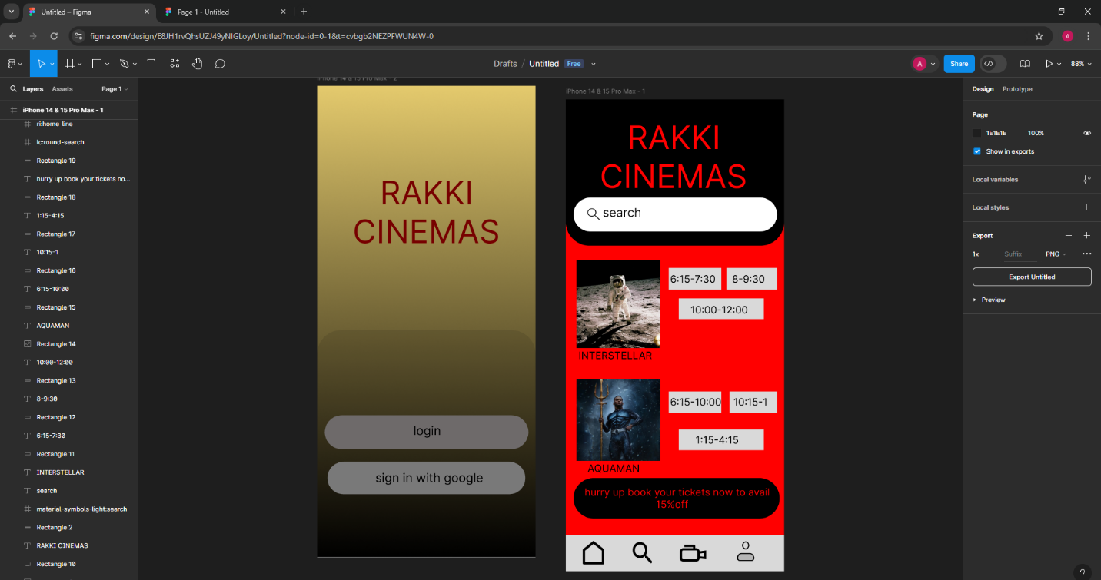

AFTER:

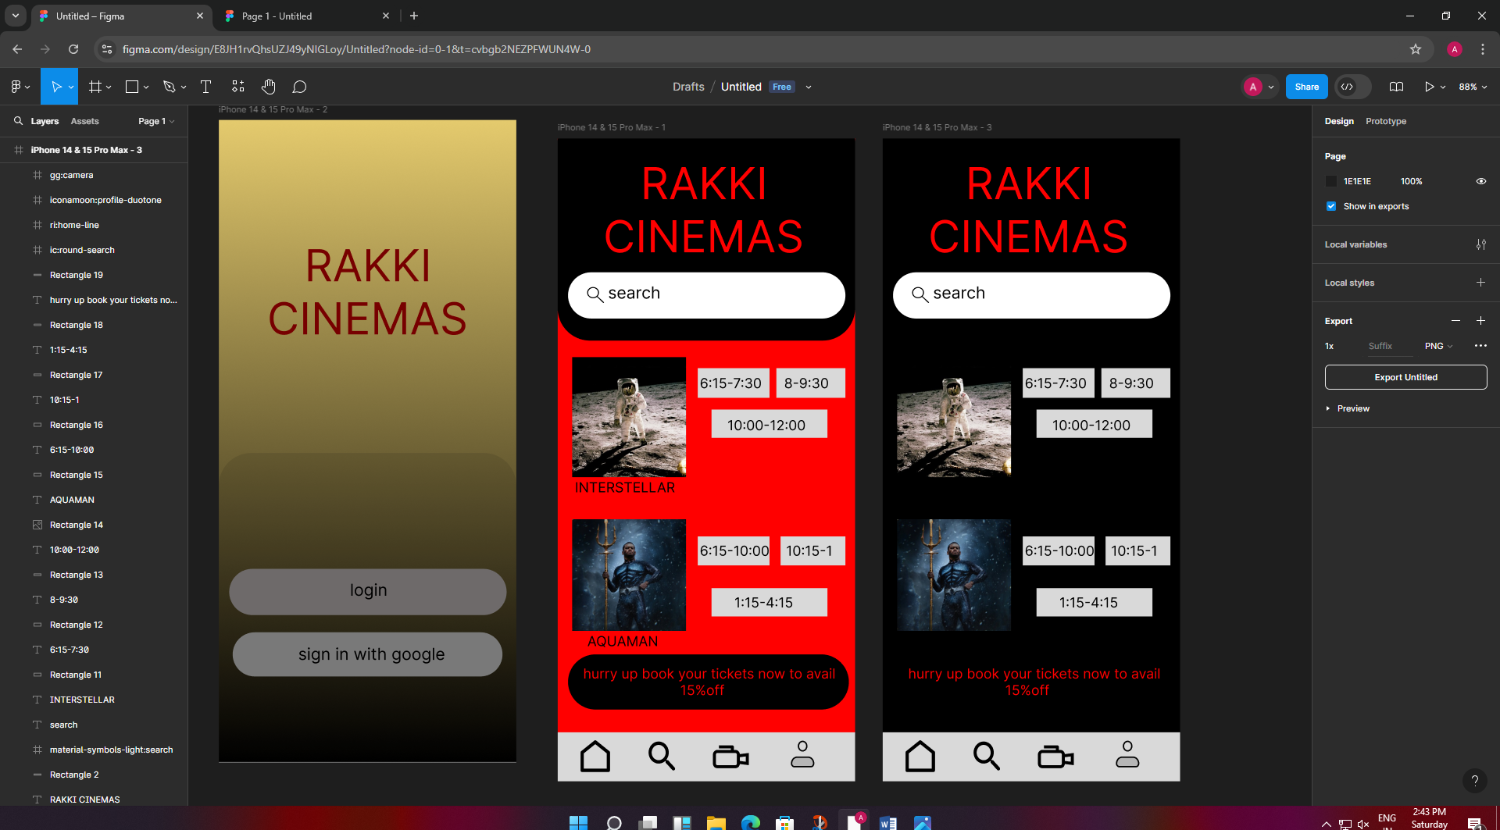

RESUT:DESIGNING A MOBILE APPLICATION IS SUCCESSFULLY DEVELOPED.